MSNP15
Unofficial Documentation

2007
Thiago
[Type the company name]
9/26/2007

Contents
How to Debug? 1
WireShark 1
P2PDecode 2
Peer-2-Peer 2
Packet Structure 2
FLAG 3
MSNSLP 3
File Transfers 3
Handshake Process 3
Transfer Process 3

- Document the handshake process
- Document the file transfer process (use a small text file)
- Document how to document? (use wireshark P2PDecode..)
- Use Wireshark and P2PDecode
- Document Classes. What do they do?

How to Debug?

WireShark

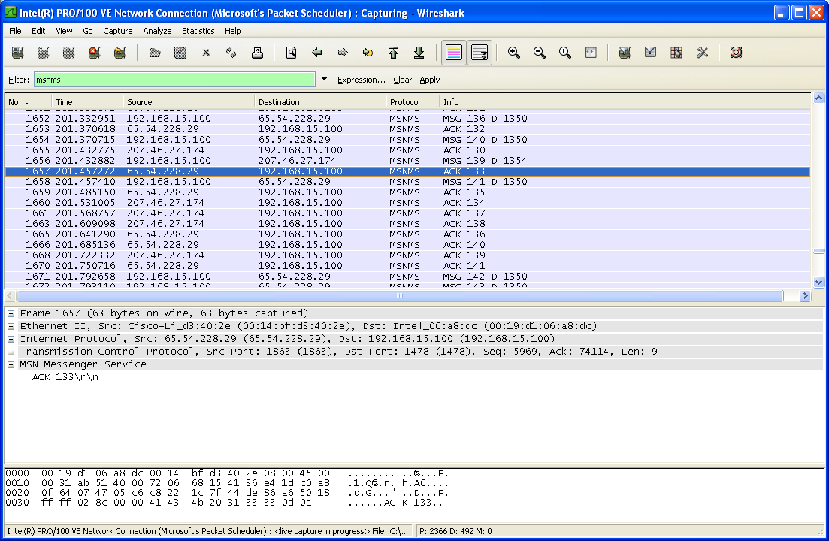

This is the wireshark user interface. You can notice that it’s filtering the “msnms” protocol.

P2PDecode

MSN Basics

Nameserver

Single Sign On

Ping (PNG)

Ping Reply (QNG)

Switchboard

Unified User Notification (UUN)

Client: UUN <TrId> <receivers e-mail address> <type> <payload length>\r\n<payload data>
Server: UUN <TrId> OK\r\n

Unified Buddy Notification (UBN)

Server: UBN <senders e-mail address> <type> <payloadlength>\r\n<payload data>

MSNSLP

Peer-2-Peer

P2P packets travels inside SLP packets, on the inner body.

Packet Structure

Field | Description | Offset | Size
SessionID | The Session ID. | 0 | DWORD
BlobID | Identifier of the blob. | 4 | DWORD
BlobOffset | Offset in the current blob. | 8 | QWORD
BlobSize | Size of the blob. | 16 | QWORD
ChunkSize | Size of the chunk. | 24 | DWORD
Flags | Flags. | 28 | DWORD
DW1 | Depends on blob. | 32 | DWORD
DW2 | Depends on blob. | 36 | DWORD
QW1 | Depends on blob. | 40 | QWORD

FLAG

Mask | ID | Description
0x1 | TLP_NAK
0x2 | TLP_ACK | Acknowledgement.
0x4 | TLP_RAK | Request TLP_ACK, still only partly known, should be TLP_ACKed. Presumably this is when you don't receive an TLP_ACK within some time limit you send a RAK and expect an ACK.
0x8 | TLP_RST | The client should flush any pending data to be sent, and possibly more?
0x10 | TLP_FILE | Whether the blob should be stored in a file (1 == file, 0 == memory)
0x20 | TLP_EACH | If set, the application should be notified on each chunk, if not set, it should only be notified when the blob has been fully received.
0x40 | TLP_CAN | The transfer has been canceled.
0x80 | TLP_ERR
0x100 | TLP_KEY | Control packet containing the key to authenticate with, key being 16 bytes long and stored in DW1, DW2 and QW1
0x200 | TLP_CRYPT | Whether encryption is enabled

MSNSLP

File Transfers

Handshake Process

On the latest MSN clients (13-15?), the handshake process is done with the UUN (sending) and UBN (receiving) commands. The handshake process is responsible for negotiating the transfer method and the connection/nat traversal method.
- Sending the invitation
The invitation is done by sending an “application/x-msnmsgr-transreqbody” as the content-type of the packet with the UUN command sent thru the switchboard, like this:
UUN 59 msntest1@test.com 3 592
INVITE MSNMSGR:msntest1@test.com MSNSLP/1.0
To: <msnmsgr:msntest1@test.com>
From: <msnmsgr:msntest2@test.com>
Via: MSNSLP/1.0/TLP ;branch={BC7B658F-C2D0-4FBC-8E67-A3F5C6E8EAC1}
CSeq: 0
Call-ID: {F13B5C79-0126-458F-A29D-747C79C56530}
Max-Forwards: 0
Content-Type: application/x-msnmsgr-transreqbody
Content-Length: 263

Bridges: TRUDPv1 TCPv1 SBBridge TURNv1
NetID: 1745618877
Conn-Type: Port-Restrict-NAT
TCP-Conn-Type: Port-Restrict-NAT
UPnPNat: false
ICF: false
Hashed-Nonce: {85AEDF2C-451F-6285-3B1B-416FBE1D3219}
SessionID: 0
SChannelState: 0
Capabilities-Flags: 1

- Receiving the invitation
The invitation is received by the receiving client as an UBN command with an “application/x-msnmsgr-transreqbody” content-type, like this:

UBN msntest2@test.com 3 592
INVITE MSNMSGR:msntest1@test.com MSNSLP/1.0
To: <msnmsgr:msntest1@test.com>
From: <msnmsgr:msntest2@test.com>
Via: MSNSLP/1.0/TLP ;branch={BC7B658F-C2D0-4FBC-8E67-A3F5C6E8EAC1}
CSeq: 0
Call-ID: {F13B5C79-0126-458F-A29D-747C79C56530}
Max-Forwards: 0
Content-Type: application/x-msnmsgr-transreqbody
Content-Length: 263

Bridges: TRUDPv1 TCPv1 SBBridge TURNv1
NetID: 1745618877
Conn-Type: Port-Restrict-NAT
TCP-Conn-Type: Port-Restrict-NAT
UPnPNat: false
ICF: false
Hashed-Nonce: {85AEDF2C-451F-6285-3B1B-416FBE1D3219}
SessionID: 0
SChannelState: 0
Capabilities-Flags: 1

- Replying the invitation
The receiving client replies the invitation by sending a “application/x-msnmsgr-transrespbody” as the content-type with an UUN command thru the switchboard, as follows. The response is always sent, on accept and on decline.
UUN 18 msntest2@test.com 3 633
MSNSLP/1.0 200 OK
To: <msnmsgr:msntest2@test.com>
From: <msnmsgr:msntest1@test.com>
Via: MSNSLP/1.0/TLP ;branch={BC7B658F-C2D0-4FBC-8E67-A3F5C6E8EAC1}
CSeq: 1
Call-ID: {F13B5C79-0126-458F-A29D-747C79C56530}
Max-Forwards: 0
Content-Type: application/x-msnmsgr-transrespbody
Content-Length: 329

Bridge: TCPv1
Listening: true
Conn-Type: Port-Restrict-NAT
TCP-Conn-Type: Port-Restrict-NAT
Hashed-Nonce: {FFC37CCB-08C3-07E5-45AD-123F4CC696B8}
srddA-lanretxE4vPI: 401.21.7.981
troP-lanretxE4vPI: 8271
srddA-lanretnI4vPI: 001.51.861.291
troP-lanretnI4vPI: 8271
SessionID: 0
SChannelState: 0
Capabilities-Flags: 1

Note that the IP information is backwards (a little weird☺).
- Receiving the invitation reply
The sender client receives the invitation answer as it was sent by the receiving client, with the connection information.

UBN msntest1@test.com 3 633
MSNSLP/1.0 200 OK
To: <msnmsgr:msntest2@test.com>
From: <msnmsgr:msntest1@test.com>
Via: MSNSLP/1.0/TLP ;branch={BC7B658F-C2D0-4FBC-8E67-A3F5C6E8EAC1}
CSeq: 1
Call-ID: {F13B5C79-0126-458F-A29D-747C79C56530}
Max-Forwards: 0
Content-Type: application/x-msnmsgr-transrespbody
Content-Length: 329

Bridge: TCPv1
Listening: true
Conn-Type: Port-Restrict-NAT
TCP-Conn-Type: Port-Restrict-NAT
Hashed-Nonce: {FFC37CCB-08C3-07E5-45AD-123F4CC696B8}
srddA-lanretxE4vPI: 401.21.7.981
troP-lanretxE4vPI: 8271
srddA-lanretnI4vPI: 001.51.861.291
troP-lanretnI4vPI: 8271
SessionID: 0
SChannelState: 0
Capabilities-Flags: 1

- Updating address information
The sender client now updates the address information by sending it again to the receiving client (why?), like this:

UUN 60 msntest1@test.com 3 485
ACK MSNMSGR:msntest1@test.com MSNSLP/1.0
To: <msnmsgr:msntest1@test.com>
From: <msnmsgr:msntest2@test.com>
Via: MSNSLP/1.0/TLP ;branch={D1BBB9B8-3599-4912-9B04-2823913084B8}
CSeq: 0
Call-ID: {00000000-0000-0000-0000-000000000000}
Max-Forwards: 0
Content-Type: application/x-msnmsgr-transdestaddrupdate
Content-Length: 152

stroPdnAsrddAlanretxE4vPI: 9271:401.21.7.981
stroPdnAsrddAlanretnI4vPI: 0371:001.51.861.291
SessionID: 0
SChannelState: 0
Capabilities-Flags: 1

- Receiving the updated address information
The receiving client now receives the updated address information from the sending client (the same command, just replace the UUN with UBN).

TODO: Port-Symmetric-Nat TurnV1

Transfer Process

After the handshake process, the transfer process begins. The transfer can be done either thru the server or by direct connecting the two clients. The first method is known to be very slow (because it goes thru the msn server) and the second one is very fast (depending on the connection speed).
The accept/decline messages and the transfer itself is done by direct connection over SSL most of the times, if possible.

